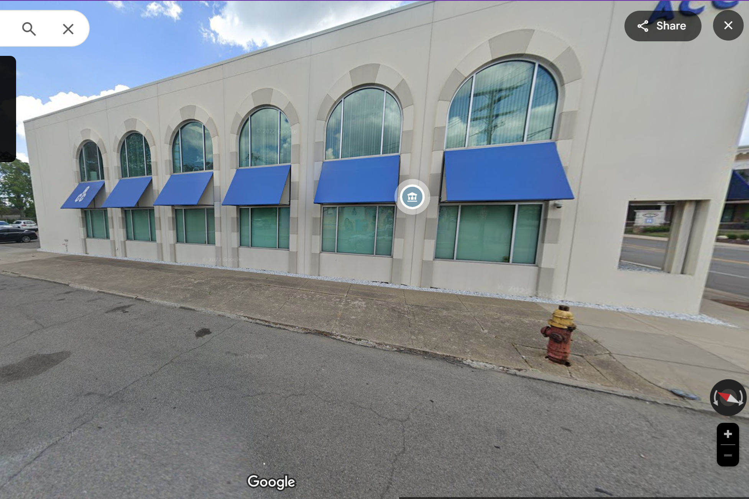
62 W. Seven Mile
Derby Street

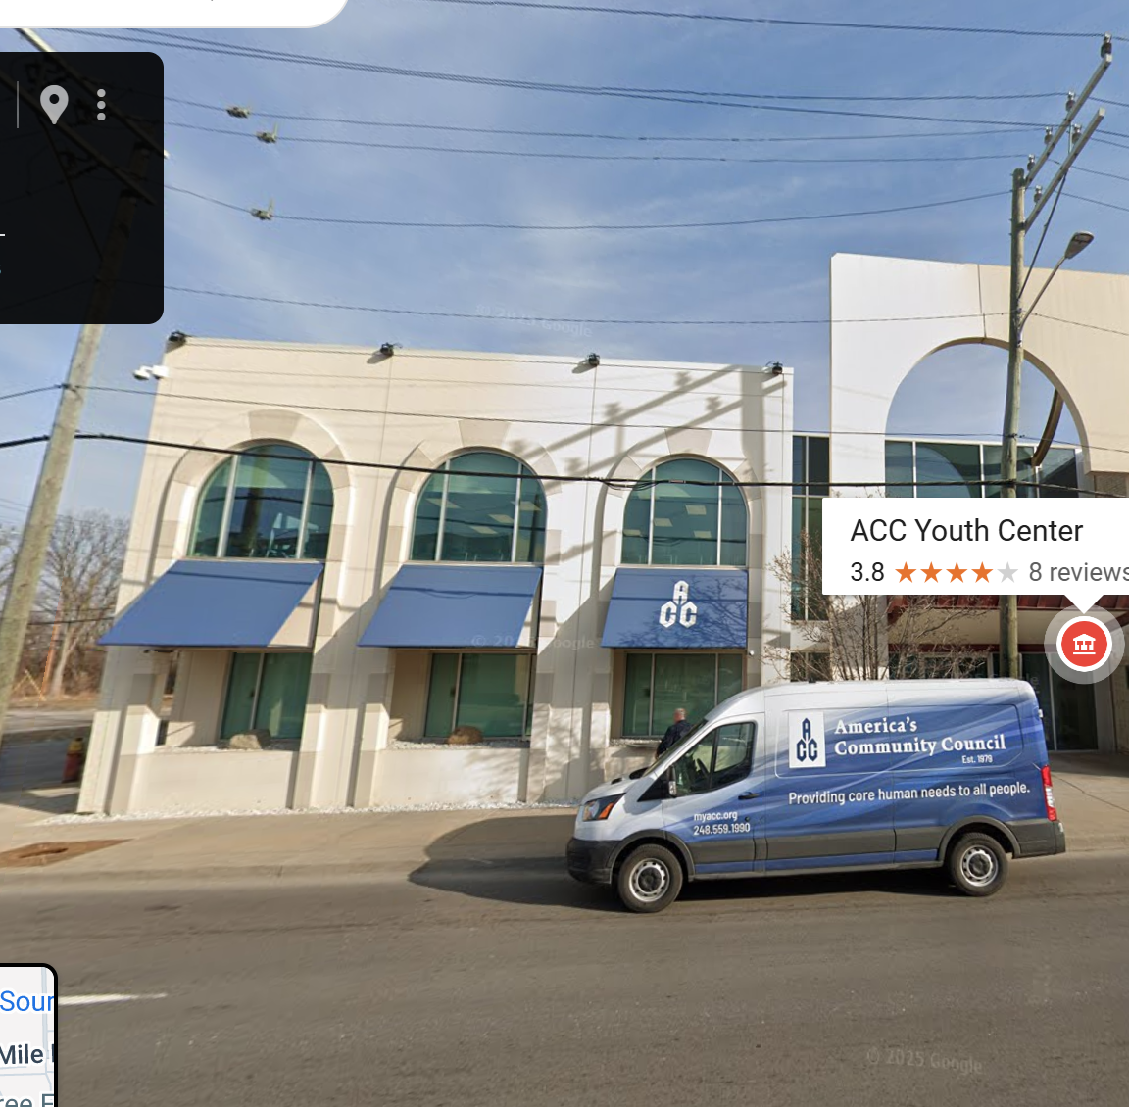
62 W. Seven Mile
Derby Street

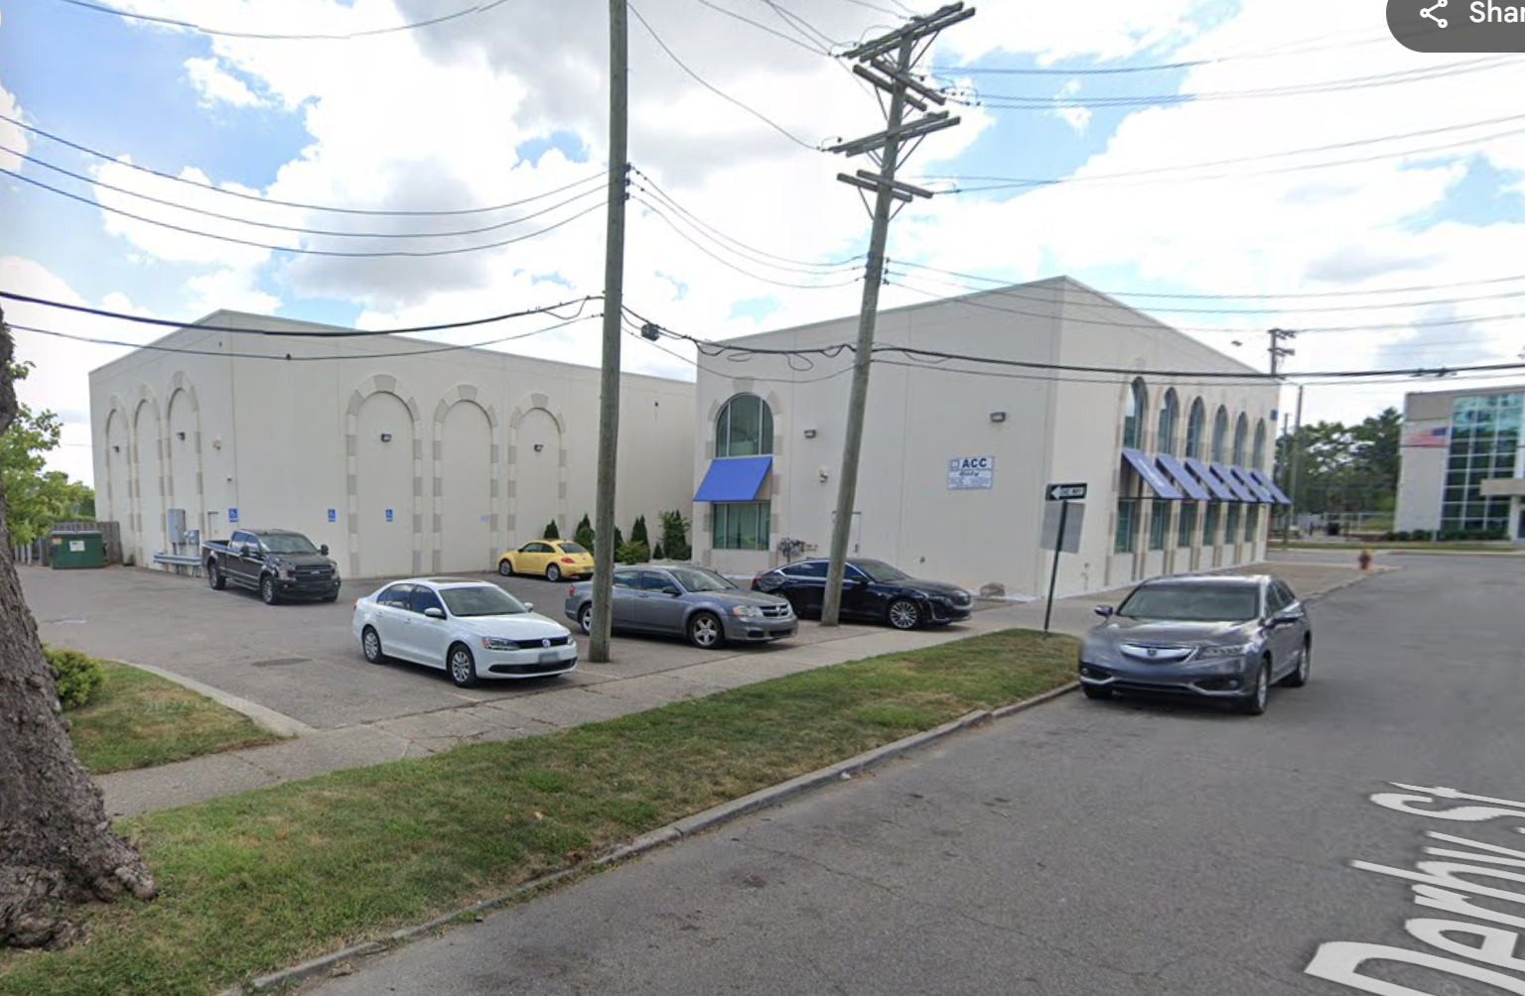
Derby Street

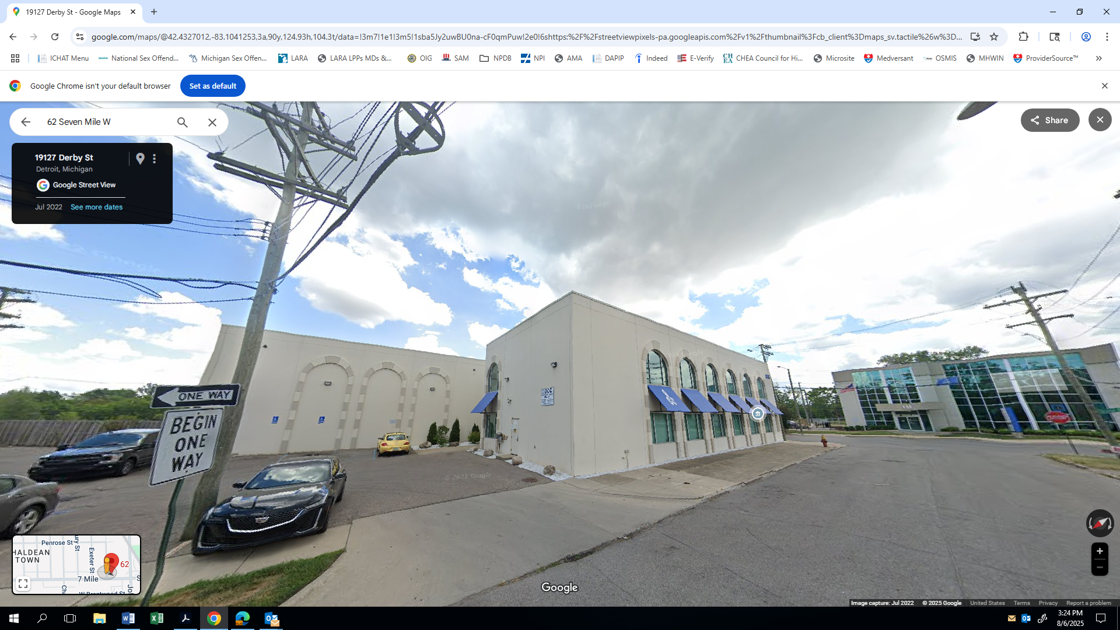
Derby Street




Sidewalk 78”
Above Grade: 8’6”
168”
168”
Awning L: 48”
106”
150”
A
CC
awnings
A
CC
A
CC
Building
62 W. Seven Mile
Detroit, MI 48203
curb
62 W. Seven Mile
light pole
Hydrant
curb
Derby Street
Parking Lot

