To: Clerk’s Office
From: The Department of Public Works
City Engineering Division
MapsandRecordsBureau@DetroitMI.Gov
(313) 224-3970

Petitioner:
Henry Ford Health System
2770 W. GRAND BLVD
Detroit, MI, 48202

On behalf of the above-mentioned petitioner the Department of Public Works: City Engineering Division is submitting a petition request for the action below. The petitioner has received a project consultation from the Department of Public Works: City Engineering Division and has been advised the following:

Type of action recommended:

Petition for encroachment into Lincoln St. for six new steel service pipes. The proposed below grade encroachment is for the Henry Ford Health Central Energy Hub (CEH) hydronic piping. The CEH hydronic piping consists of six privately owned pipes: three insulated chilled water pipes with a 36-inch outside diameter and three insulated hot water pipes with a 30-inch outside diameter, with 1-foot spacing between each pipe. The system utilizes steel service pipes with polyurethane insulation and HDPE jacket.

Raven Wright
Supervisor of Maps & Records
Department of Public Works
City Engineering Division
313-224-3985

January 16, 2025

Honorable Detroit City Council
C/o Detroit City Clerk
200 Coleman A. Young Municipal Center
2 Woodward Avenue
Detroit, Michigan 48226

RE: Giffels Webster - Request for an encroachment into the right-of-way of Lincoln St (60 ft. wide) between Baltimore St and Milwaukee Avenue.

Giffels Webster, 28 W. Adams, Suite 1200, Detroit, Michigan 48226 on behalf of Kiewit Power Constructors Co., 8900 Renner Blvd., Lenexa, Kansas, 66219 respectfully requests the following below grade encroachment into the City of Detroit public right-of-way:

    - The proposed below grade encroachment is for the Henry Ford Health Central Energy Hub (CEH) hydronic piping. The CEH hydronic piping consists of six privately owned pipes: three insulated chilled water pipes with a 36-inch outside diameter and three insulated hot water pipes with a 30-inch outside diameter, with 1-foot spacing between each pipe. The system utilizes steel service pipes with polyurethane insulation and HDPE jacket. The proposed encroachment begins at the right-of-way line at the southwest corner of Milwaukee Ave and Lincoln St, extends south 24.5 ft and spans the full 60-foot width of Lincoln St to the east. The proposed encroachment begins 3.5’ below grade and extends to 7.5’ below grade.

Limits of the requested encroachments can be found in the attachment, enclosed herein. Additional documentation further detailing the proposed encroachment for the CEH hydronic piping, including a spec sheet for the pipe material, is attached.

Giffels Webster has been asked to facilitate the requested encroachments on behalf of Kiewit Power Constructors Co. If you should have any questions, please do not hesitate to contact me at 313.962.4442 or at rjones@giffelswebster.com.

Respectfully,
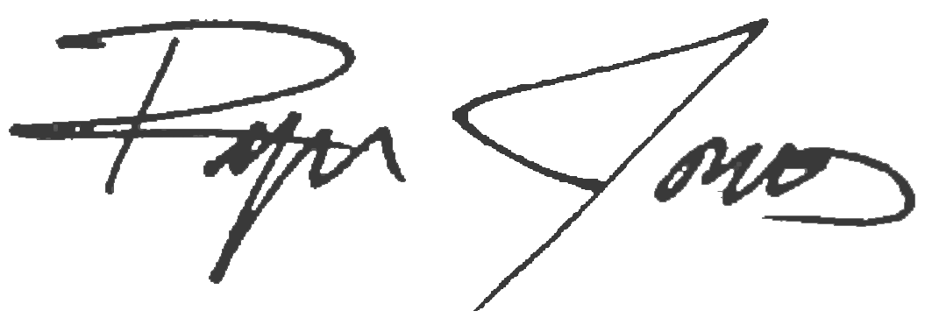

Ryan Jones, PE
Project Manager

