MAINTENANCE AGREEMENT
[6405 Lincoln St.]

This agreement (this “Agreement”) is made and entered into this _29____ day of ________November_________, 2025__, by and between the City of Detroit, a Michigan municipal corporation, acting by and through its Department of Public Works, whose address is 2 Woodward Ave., Ste. 611, Detroit, MI 48226 48202 (the “City”), and [Henry Ford Health Central Energy Hub (CEH) ], (the “Owner”) whose address is 6405 Lincoln St. Detroit, MI 48202

NOW THEREFORE, for valuable consideration, including the covenants and undertaking herein contained, it is mutually agreed as follows:

- Purpose of Agreement: The Owner holds title to a certain property described in Exhibit A attached hereto (the “Building”). The City has jurisdiction over rights-of-way adjacent to the Building. Inasmuch as persons entering or exiting from the Building may use the City right-of-way and/or to the extent that certain services benefiting the Building (for example, water and sewer) are located in the City right-of-way, the Owner has agreed to improve and maintain a portion of City right-of-way in the location (the “Maintenance Area”) and manner detailed in the plan attached as Exhibit B for the Term, as defined herein. The Detroit City Council has approved the Owner’s encroachment Petition No. x [insert encroachment petition number] to permit the Owner to build or place the encroachment described in the petition in the Maintenance Area. All costs for the construction, maintenance, permits, and use of the encroachments shall be borne by the Owner. This Agreement does not relieve the Owner from securing any other additional permits or right-of-way permits for performing work/activities in the public right-of-way. The necessary permits shall be obtained from the Department of Public Works - City Engineering Division or the Buildings, Safety Engineering and Environmental Department, as applicable.

- Financial Responsibility: It is understood that during the Term, all physical improvements and repairs to the Maintenance Area, as set forth herein, shall be at the sole cost and expense of the Owner, subject to any express limitations set forth in this Agreement. The Owner agrees to maintain the Maintenance Area and to repair any damage to the Maintenance Area until the earlier of the: (i) expiration of the Term, (ii) termination of this Agreement, (iii) removal of the Maintenance Area, or (iv) end of the Maintenance Area’s useful life.

If the City proposes to carry out work or issues a permit allowing a private party to carry out work, in or near the Maintenance Area, the City shall use good faith efforts to notify the Owner of the City’s plans or the permit issued, as applicable. Emergency work conducted by the City in or near the Maintenance Area shall be carried out without any requirement to notify the Owner. Any work conducted in or near the Maintenance Area shall only be required to be repaired pursuant to the Department of Public Works - City Engineering Division’s Standard Specifications.

- Indemnification and Release: The Owner hereby agrees to indemnify, defend and hold the City harmless from all loss, costs, expense, actions, claims of action, damages, and liability (including attorneys’ fees and costs) for injury to or death of any person or persons and for the damage to or destruction of property caused by the Owner’s actions or omissions in the course of or resulting from the improvements and maintenance activities contemplated by this Agreement. The Owner hereby agrees to waive, release, and discharge the City from any and all liability, claims, demands, and causes of action whatsoever, legal and equitable, because of damages, losses, or injuries to the Owner or the Owner’s property or both, arising from or related to the Owner’s activities related to the improvements and maintenance activities contemplated by this Agreement.

- Insurance: The Owner covenants and agrees, at its sole cost and expense, to maintain or cause to be maintained for the mutual benefit of it and the City Comprehensive General Liability insurance on an occurrence form against claims for bodily injuries (including, but not limited to, death) or property damage (including, but not limited to, destruction) at any time occurring in the course of or resulting from work carried out by the Owner upon, in or about the Maintenance Area, at combined single limits of not less than Two Million Dollars ($2,000,000.00) per occurrence and Four Million Dollars ($4,000,000.00) in the aggregate. Such insurance coverage shall name the City of Detroit as an additional insured and shall provide that the same may not be cancelled or materially modified without prior written notice by certified mail to the City to the attention of the Office of the Chief Financial Officer, Risk Management Division2 Woodward Ave., Ste 802, Detroit, MI 48226. Said coverage may be evidenced by a certificate of insurance issued upon so-called “blanket” coverage, or by either a certificate or the original of an insurance policy effecting such coverage. The insurance shall be primary and any such insurance or self-insurance maintained by the City shall be secondary and non-contributory and excess. The Owner shall be responsible for payment of all premiums and deductibles relating to such insurance. The provisions requiring the Owner to carry or cause to be carried such insurance shall not be constructed as waiving or restricting the liability of the Owner under this Agreement.

- Term: The term of this Agreement (the “Term”) shall commence on the date of this Agreement and continue for five (5) years, at the end of the five (5) year period the Owner may exercise the option to extend for an additional five (5) year period after obtaining approval from the City. This Agreement may be terminated or extended as follows:

  - The City may terminate this Agreement prior to the end of the Term in the event the City has designed and has committed to implement a uniform scheme for the improvement of an area of City right-of-way that encompasses the Maintenance Area and other adjacent City-owned property and/or rights-of-way. The aforesaid may include widening of streets or sidewalks and relocation of water or sewer facilities.

  - The Owner may terminate this Agreement prior to the end of the Term if it grants a mortgage lien or security interest in the Building or portion thereof.

  - In the event a party elects to terminate this Agreement pursuant to Sections 5(a) or
5(b) above, such party shall deliver to the other party written notice of such election at least thirty (30) days prior to the date on which such termination is to be effective.

  - This Agreement shall terminate if the Owner sells or ground leases the Building.

  - Following the expiration of the additional five (5) year period (but not the early termination) of this Agreement, this Agreement shall automatically continue on month-to-month basis subject to final termination by either party upon delivery of at least thirty (30) days’ written notice to the other party.

  - The City may terminate this Agreement without cause at any time, by giving written notice to the Owner at least thirty (30) days prior to the date on which termination shall be effective.

- Governing Law: This Agreement shall be governed by and construed in accordance with the laws of the State of Michigan.

- Entire Agreement: This Agreement constitutes the entire agreement between the parties. Any prior agreements, negotiations or representations not expressly set forth in this Agreement are of no force or effect. Any amendment to or modification of this Agreement shall be of no force or effect unless it is in writing and signed by an authorized signatory for each of the parties.

- Successors and Assigns: This Agreement is for the exclusive benefit of the parties stated herein and shall not be deemed to give any legal or equitable right, remedy or claim whatsoever to any other person. The Owner may not assign this Agreement to any purchaser of the Building, any affiliate of the Owner, or any unaffiliated third party purchaser of the Building without the prior written consent of the City. The Owner shall notify the City in writing no later than sixty (60) days prior to such assignment, and the City may, by written notice to the Owner within thirty (30) days after receiving such notice from the Owner, accept such assignment or terminate this Agreement. If the City does not accept such assignment or the assignee fails to provide the City with an acceptance of the assignment and its agreement to be bound by all of the terms hereof, then the City may terminate this Agreement at any time thereafter upon written notice to the Owner..

- Permitted Improvements or Modifications: Any desired improvement or modification to the Maintenance Area shall be subject to the City’s prior written approval. The Owner shall not install or construct in the Maintenance Area any structure, fixture, furniture, or equipment (including but not limited to signs, lighting, fixtures, shades, canopies, or awnings) as may obstruct or in any way encroach upon the Maintenance Area except as set forth in Exhibit B and otherwise properly permitted by the City.

- Rights of the City: The parties understand and agree that this Agreement in no way limits the property rights of the City with respect to the Maintenance Area.

- Maintenance Obligations of the Owner: During the Term, the Owner shall be responsible for the improvement and maintenance activities related to the Maintenance Area as set forth on Exhibit B at its sole cost and expense.

IN WITNESS WHEREOF, the City and the Owner, by and through their authorized officers and representatives, have executed this Agreement as follows:

_______________________________,
a _______________ _______________

By: _______________________________________________________
(Signature)
Print Name: ______________________________________________

Its: _______________________________________________________
(Duly Authorized Representative)

The City of Detroit, through its Department of Public Works - City Engineering Division

By: _______________________________________________________
(Signature)
Print Name: ______________________________________________

Its: _______________________________________________________

Exhibit A

BUILDING DESCRIPTION
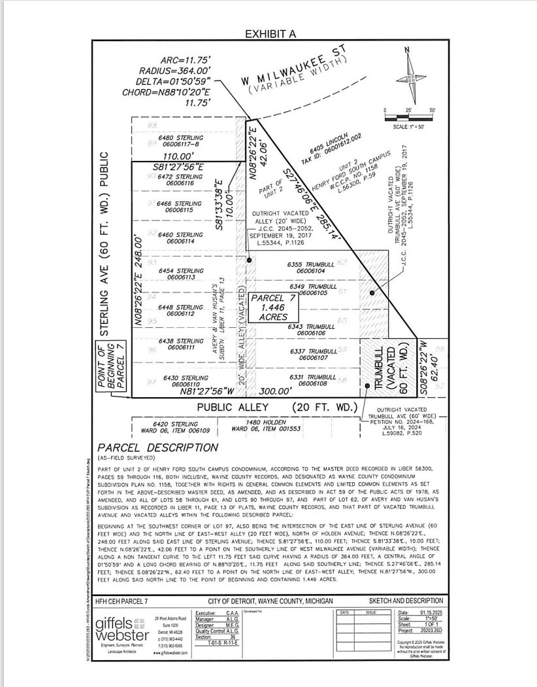

Exhibit B

Maintenance Area and Plan for Improvements; Related Maintenance Responsibilities.

Six privately owned steel service pipes, within Lincoln St., 60 ft. wide, beginning at the right-of-way line at the southwest corner of Milwaukee Ave., 60 ft. wide and Lincoln St., 60 ft. wide, extends south 24.5 ft. and spans the full 60 ft. width of Lincoln St. to the east. Lying easterly of and adjacent to lot 44 and lying westerly of and adjacent to lot 33 of the “Avery & Van Husan’s Subdivision” as recorded in Liber 11 Page 13 of Plats, Wayne County Records. Said six privately owned pipes shall be installed 3.5’ below grade and extend to 7.5’ below grade.

[to be completed as applicable to each project]

