August 12, 2024

Honorable Detroit City Council
C/o Detroit City Clerk
200 Coleman A. Young Municipal Center
2 Woodward Avenue
Detroit, Michigan 48226

RE: Giffels Webster – Request to vacate the north/south alley and the east/west alley bounded by Lisette Street (60 feet wide), Montclair Street (60 feet wide), Freud Street (60 feet wide), and Meadowbrook Street (60 feet wide).

Giffels Webster, 28 W. Adams, Suite 1200, Detroit, Michigan 48226 on behalf of the Neighborhood Development Corporation, 500 Griswold, Suite 2200, Detroit, MI 48226, respectfully requests the following outright vacation of the north/south alley between Meadowbrook Street and Montclair Street and the east/west alley between Lisette Street and Freud Street, in the City of Detroit.

- Vacation of the north/south and east/west alley bounded by the above referenced roadway segments for the development of a neighborhood park. Refer to the attached sketch for further clarification.

The requested alley vacation is a critical part of the Jefferson Village Park redevelopment project. Please refer to the attached detailed sketch for further clarification of the alley vacation.

If you should have any questions, please do not hesitate to contact me at (P) 313.962.4442 (M) 248.318.7988 or at tthomas@giffelswebster.com.

Respectfully,
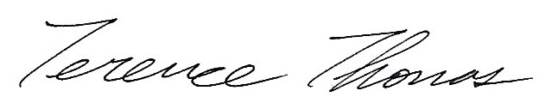
Terence Thomas
Senior Project Manager
Giffels Webster

attachment

