March 7, 2023

City of Detroit City Council

Coleman A. Young Municipal Center

2 Woodward Avenue, Suite 1340

Detroit, Michigan 48226

**RE: Request to Install 3 Groundwater Monitoring Wells and 3 Soil Borings Within the West Grand Boulevard Right of Way and Dexter Avenue Right of Way, Detroit, Wayne County, Michigan**

To Whom It May Concern,

PM Environmental (PM) is under contract with Diversified Fuels Properties (Owner) to investigate the extent of impact resulting from an open leaking underground storage tank (LUST) gasoline release (C-0146-20) at the Citgo gasoline dispensing station located at 2021 West Grand Boulevard, Detroit, Wayne County, Michigan.

PM is requesting approval, in addition to submitting a permit application, to conduct subsurface work on behalf of Diversified Fuels Properties within the West Grand Boulevard right of way (ROW) and Dexter Avenue ROW as shown in the attached Figure 1. PM will install six (7) soil borings to a total depth of 20 feet below ground surface to collect soil samples and convert three (3) of the soil borings to permanent groundwater monitoring wells. The investigation will begin as soon as the permit has been granted and will continue until regulatory closure of release C-0146-20 is achieved. Following closure, all well materials will be removed from the ground and the area returned to normal conditions.

If you have any questions related to this report, please do not hesitate to contact our office at (248) 336-9988 or via email at [kayla.snellenberger@pmenv.com](mailto:kayla.snellenberger@pmenv.com).

Sincerely,

**PM Environmental, Inc.**

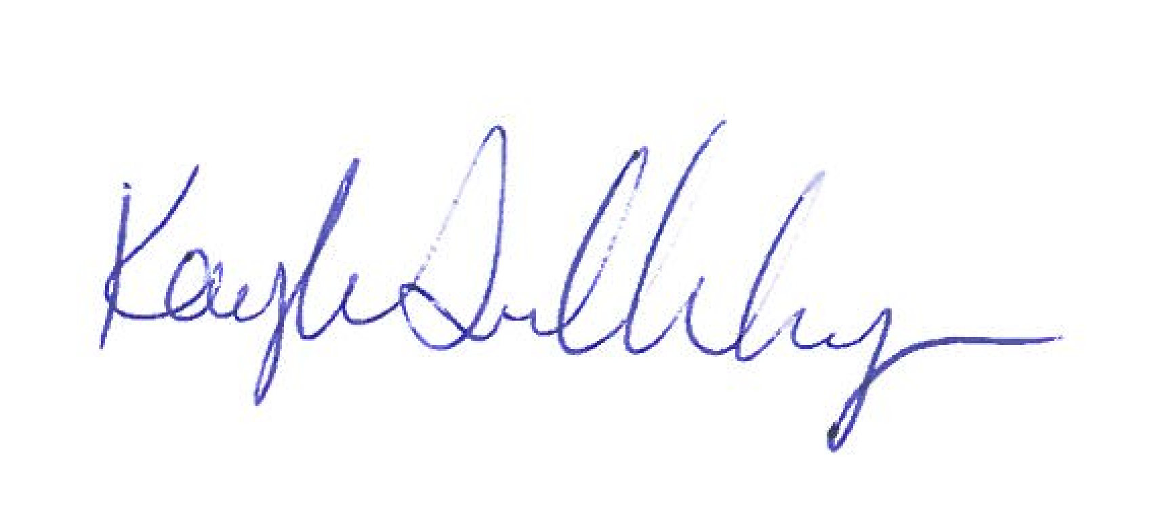

Kayla Snellenberger

Staff Scientist

Attached:

Figure 1: Proposed Soil Boring/ Permanent Monitoring Well/ Soil Gas Sample Location Map

Typical Monitoring Well Construction Detail