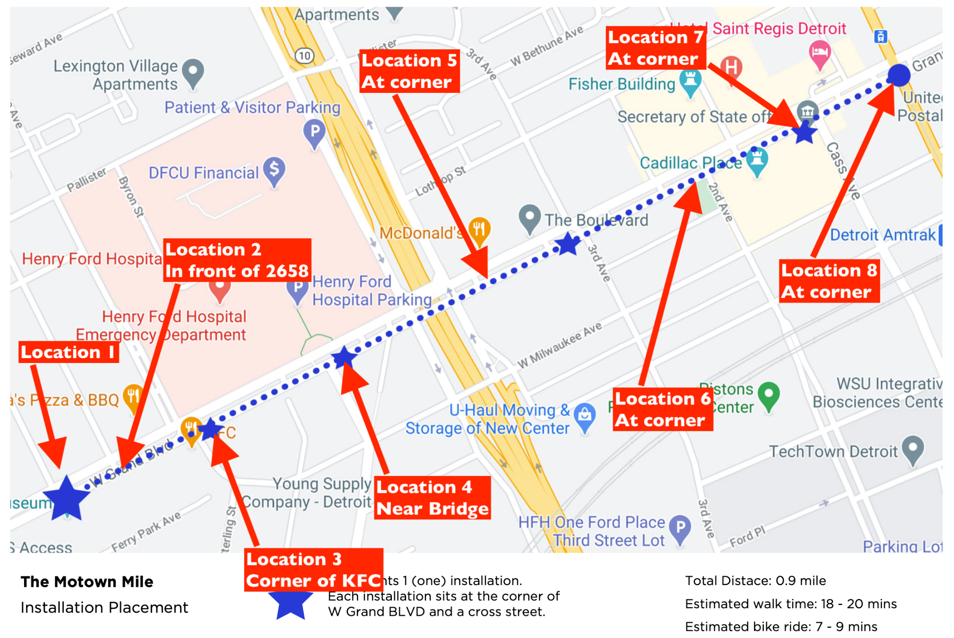

Location 1: 2648 W Grand Blvd
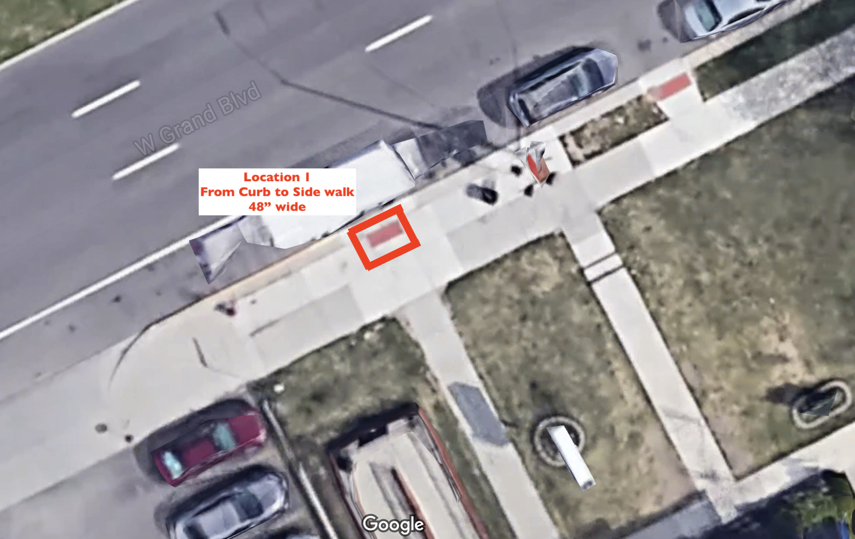
Location 2: 2658 W Grand Blvd, west of curb cut. 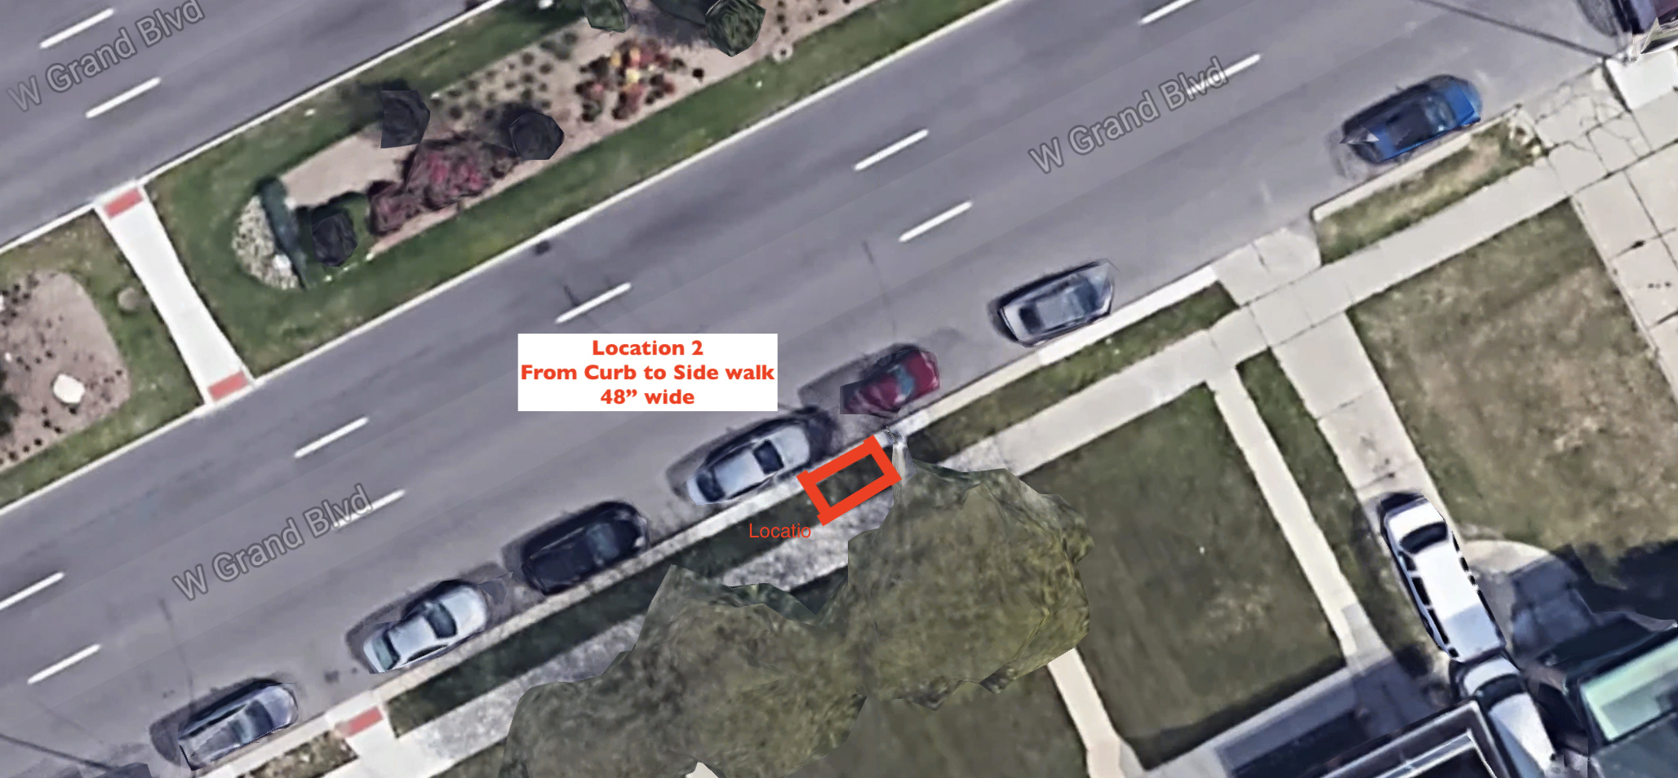

Location 3: 2716 W Grand Blvd, west of drive thru exit.

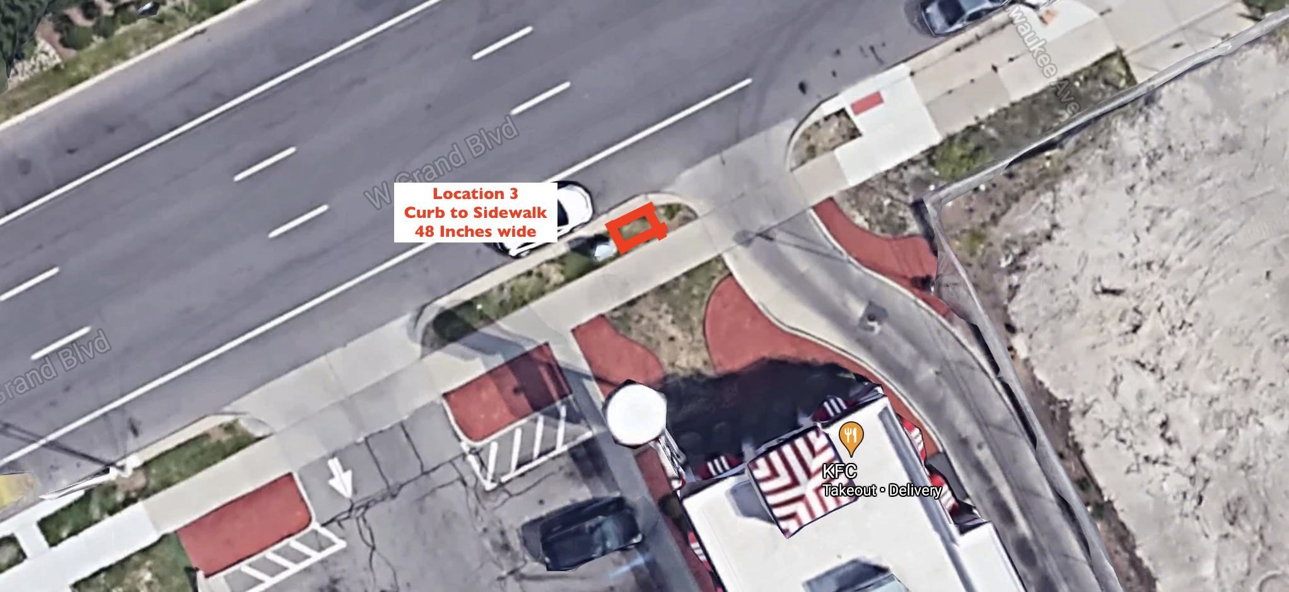

Location 4: 2800 W Grand Blvd, east of cross walk
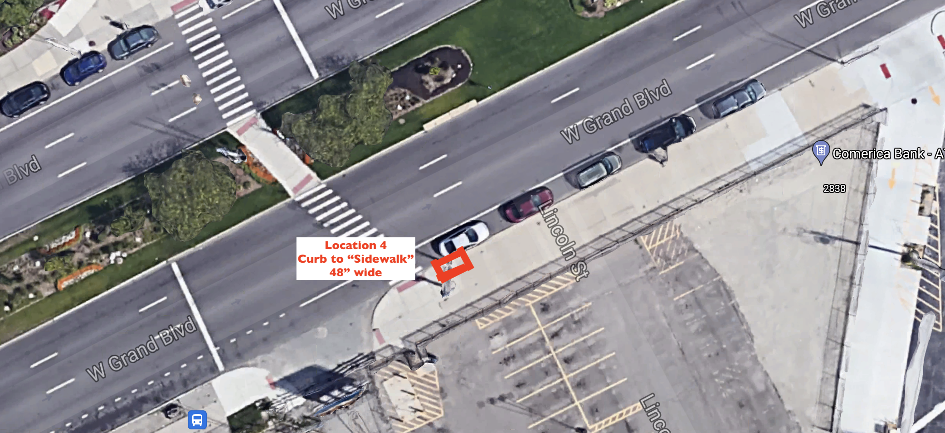

Location 5: 2894 W Grand Blvd, east of curb cut.

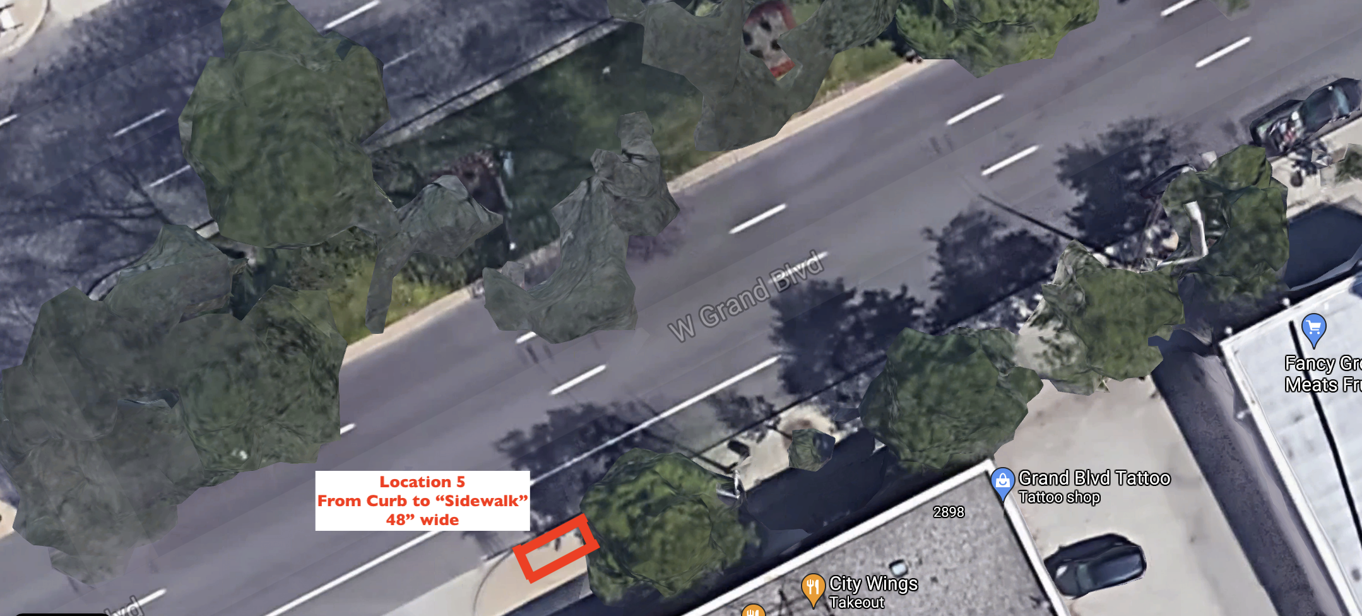

Location 6: 2998 W Grand Blvd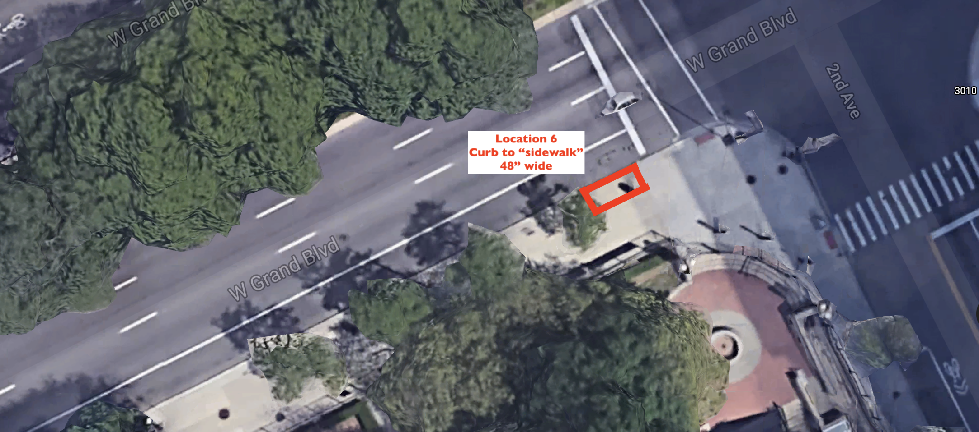

Location 7: 3044 W Grand Blvd

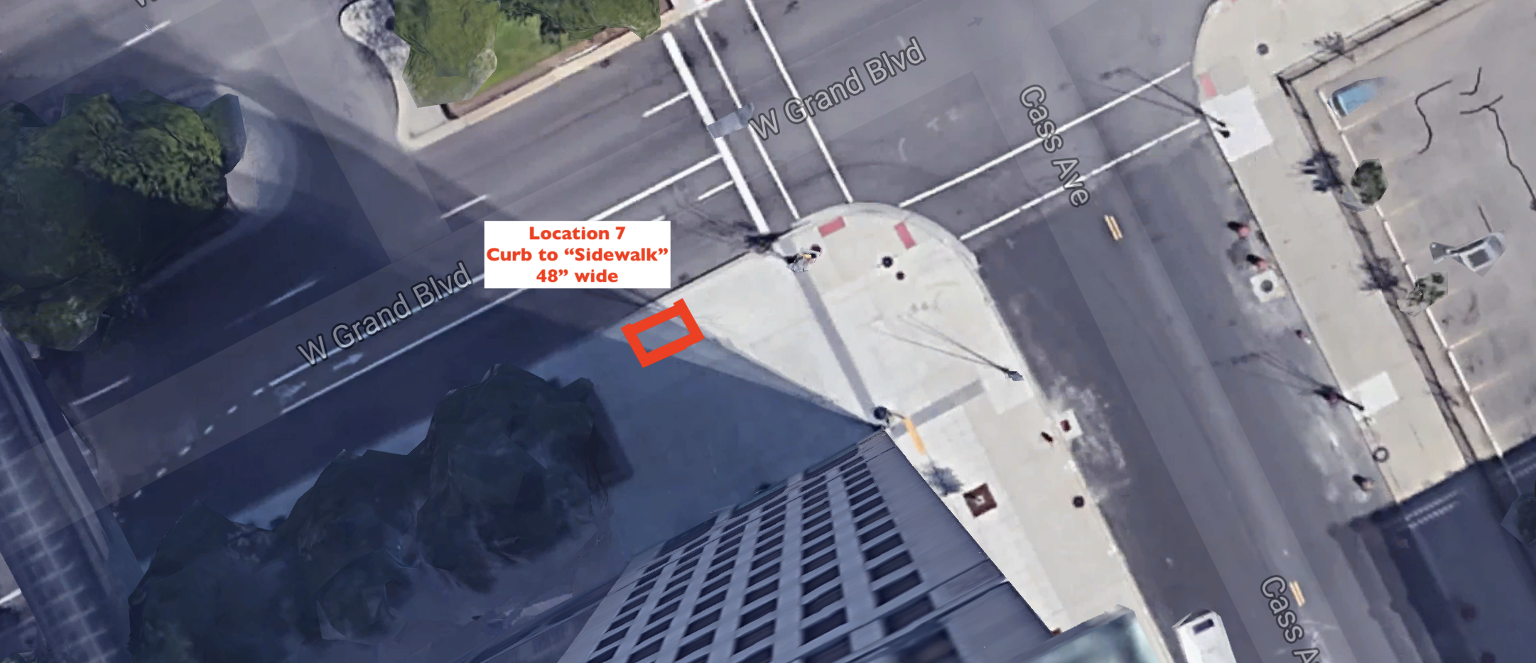

Location 8: 6565 Woodward; southwest corner of W Grand Blvd and Woodward