Keith Harrington,

The City of Detroit is contacting you regarding the right-of-way status of Fargo Street as it dead-ends into the playfield west of Prevost Street. In review of the mentioned segment of Fargo Street, the City has concluded that it is eligible for vacation with conversion to utility easement. The vacation of right-of-way means it seizes to exist as a public right-of-way and ownership allocated to adjacent landowners. Per the State of Michigan Act, the allocation of vacated right-of-way uses the centerline of the right-of-way as the dividing line of ownership when all adjacent owners are located within the same platted subdivision. In the case of the mentioned segment of Fargo Street, the owners of 20001 Prevost Street and 19979 Prevost Street are the two adjacent owners within the same platted subdivision and therefor would be entitle to land with the approval of the proposed vacation. The mentioned segment of Fargo Street is 60 ft. wide; therefor the two mentioned adjacent owners would receive 30 ft. each.

Vacation with conversion to easement:

Street and alleys contain necessary utility infrastructure such as main water lines, sewer lines, and overhead utility wires. Vacated right-of-way often requires access easements to allow utility companies right to access utility assets for maintenance. Easements restrict owners from building structures or other permeant features that would prevent utility companies from accessing utilities. Easements, however, do allow owners to fence property lines within the easement.

Changes to Parcel Assessment and Drainage Fees:

Current landowners will not be subject to increased tax assessments or drainage fees. The increase of the land acreage is updated when the next sale of the land occurs or if any improvements occur within the easement, such as surface paving or any improvement requiring a permit from a City department. There is otherwise no cost to you for moving forward with this proposal.

We are requesting your input:

We will need your input before the City moves forward with vacating the mentioned segment of Fargo Street. Please contact us at MapsandRecordsBureau@detroitmi.gov or by calling us at 313-224-3970 to express your support or objection to this proposal. Please call us if you require further information.

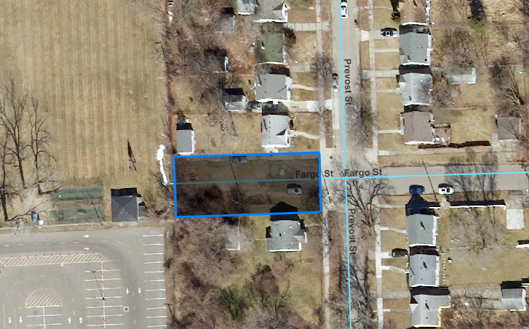

Thank you for your consideration,

City of Detroit, Department of Public Works
Maps and Records Bureau
313-224-3970
MapsandRecordsBureau@detroitmi.gov

