Step 1: Download the ArcGIS Map on your phone


Step 3: Click on Google Map to find the route to the speed hump
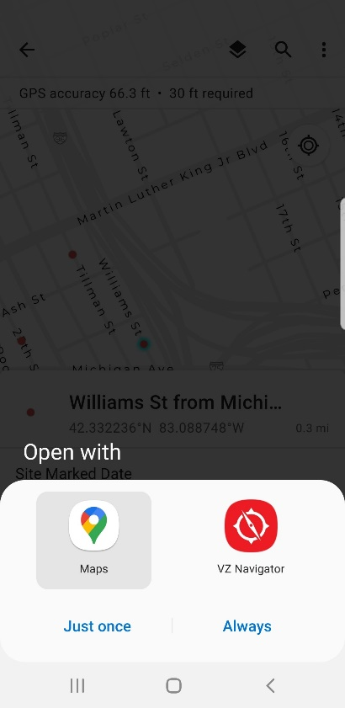
Step 2: Open the map and click on the location of the speed hump. Then click on the direction button to find the route.
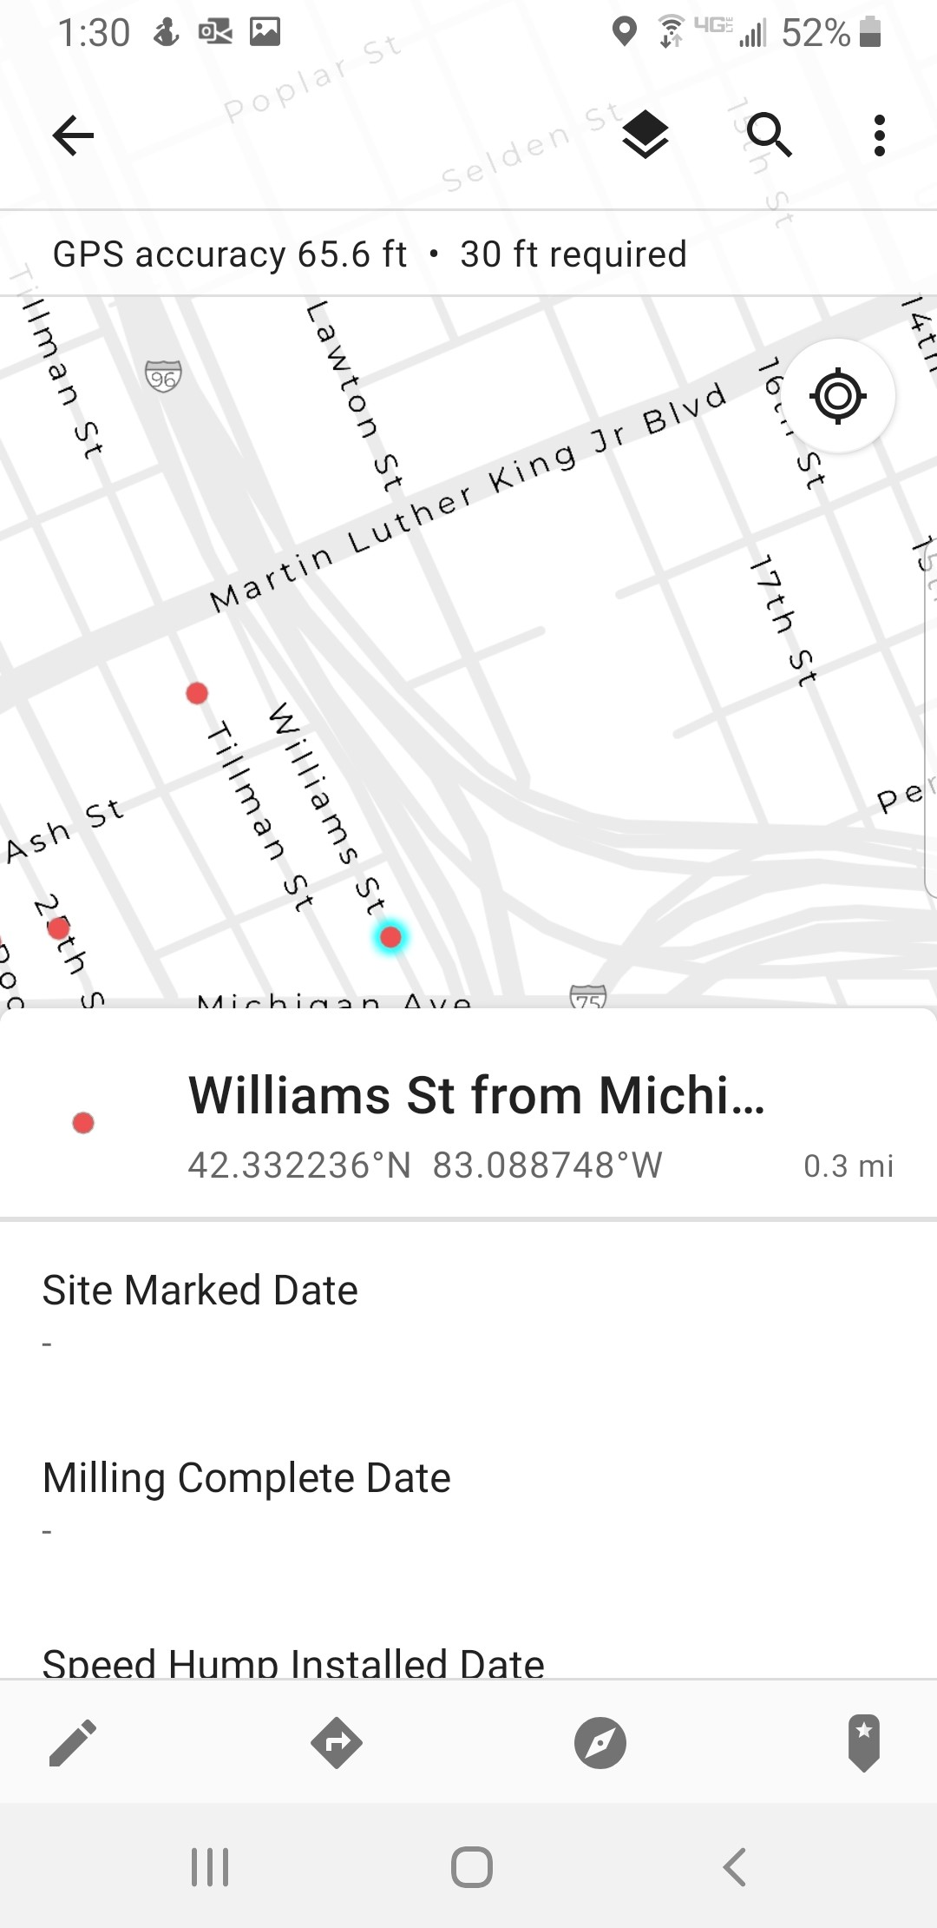
Direction Button

Step 4: Use Google Map to find the route to the speed hump
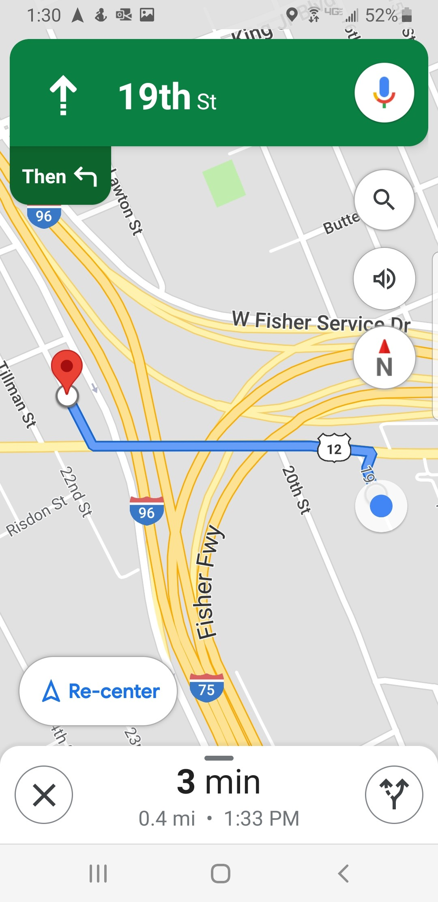

Step 5: When you arrive to the location of the speed hump. Change the base map to Satellite view.
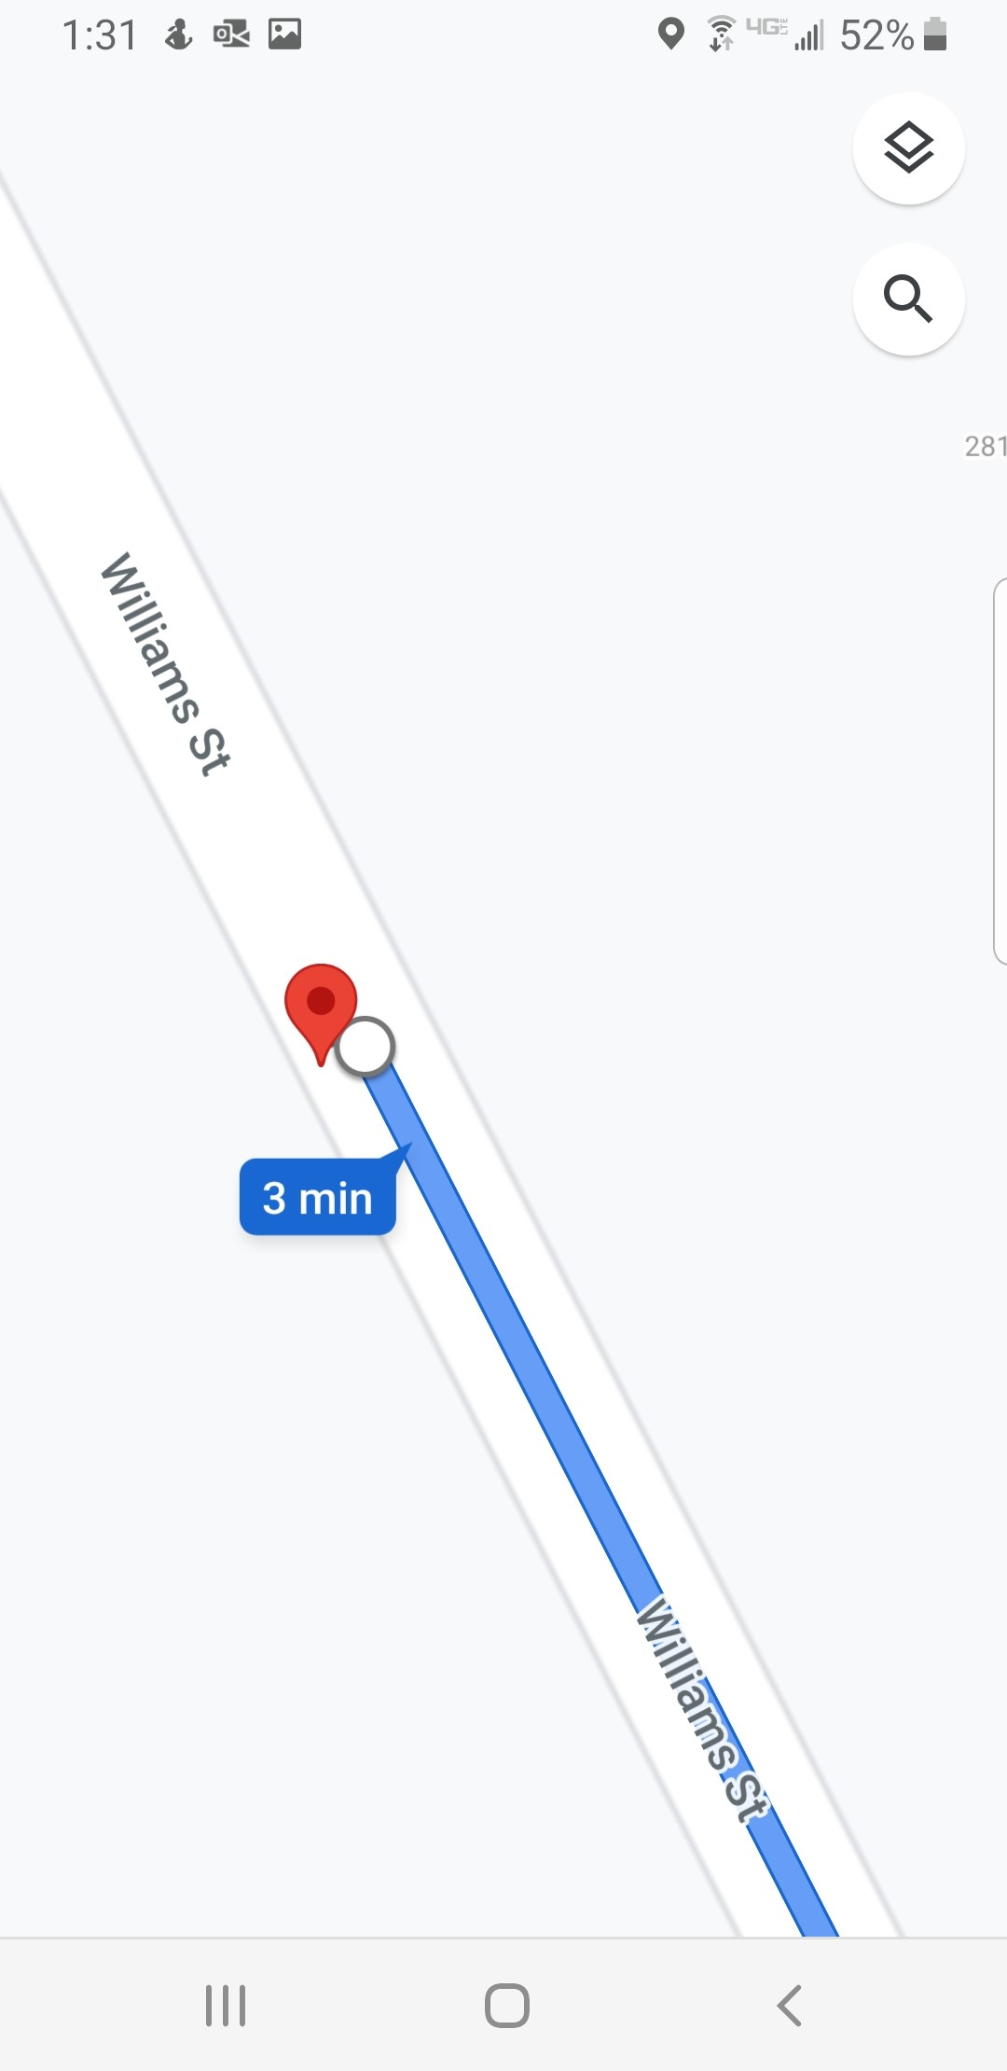
Base map change Button

Step 7: Mark the speed hump in front of the house: 2821 Williams St
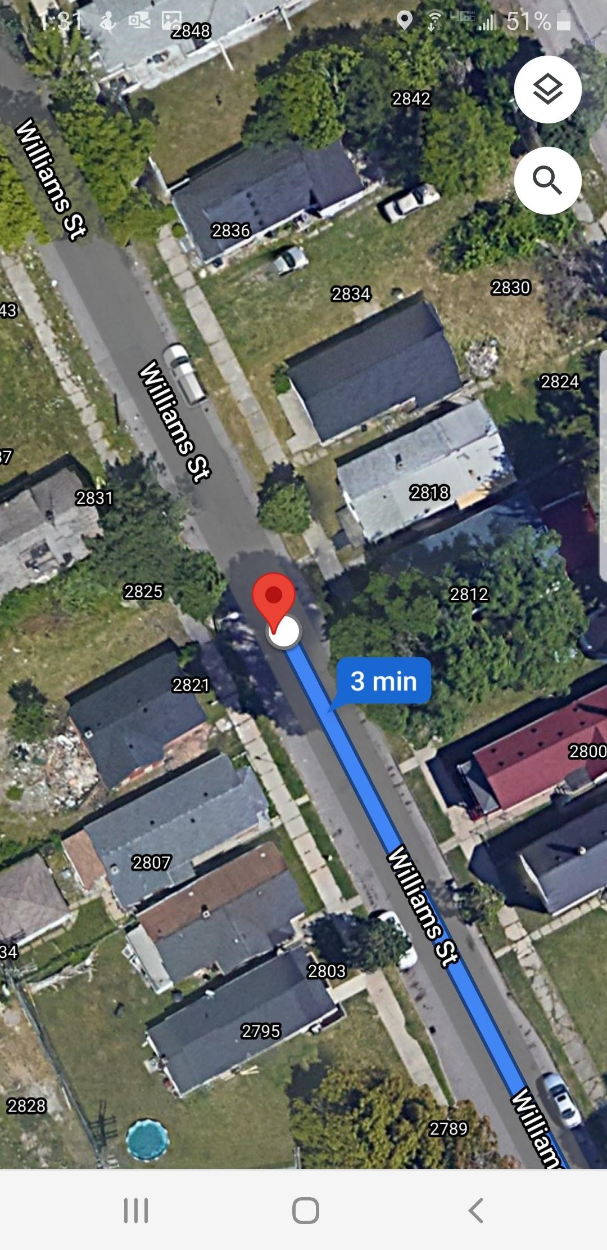
Step 6: Click on the Satellite Button to change base map.
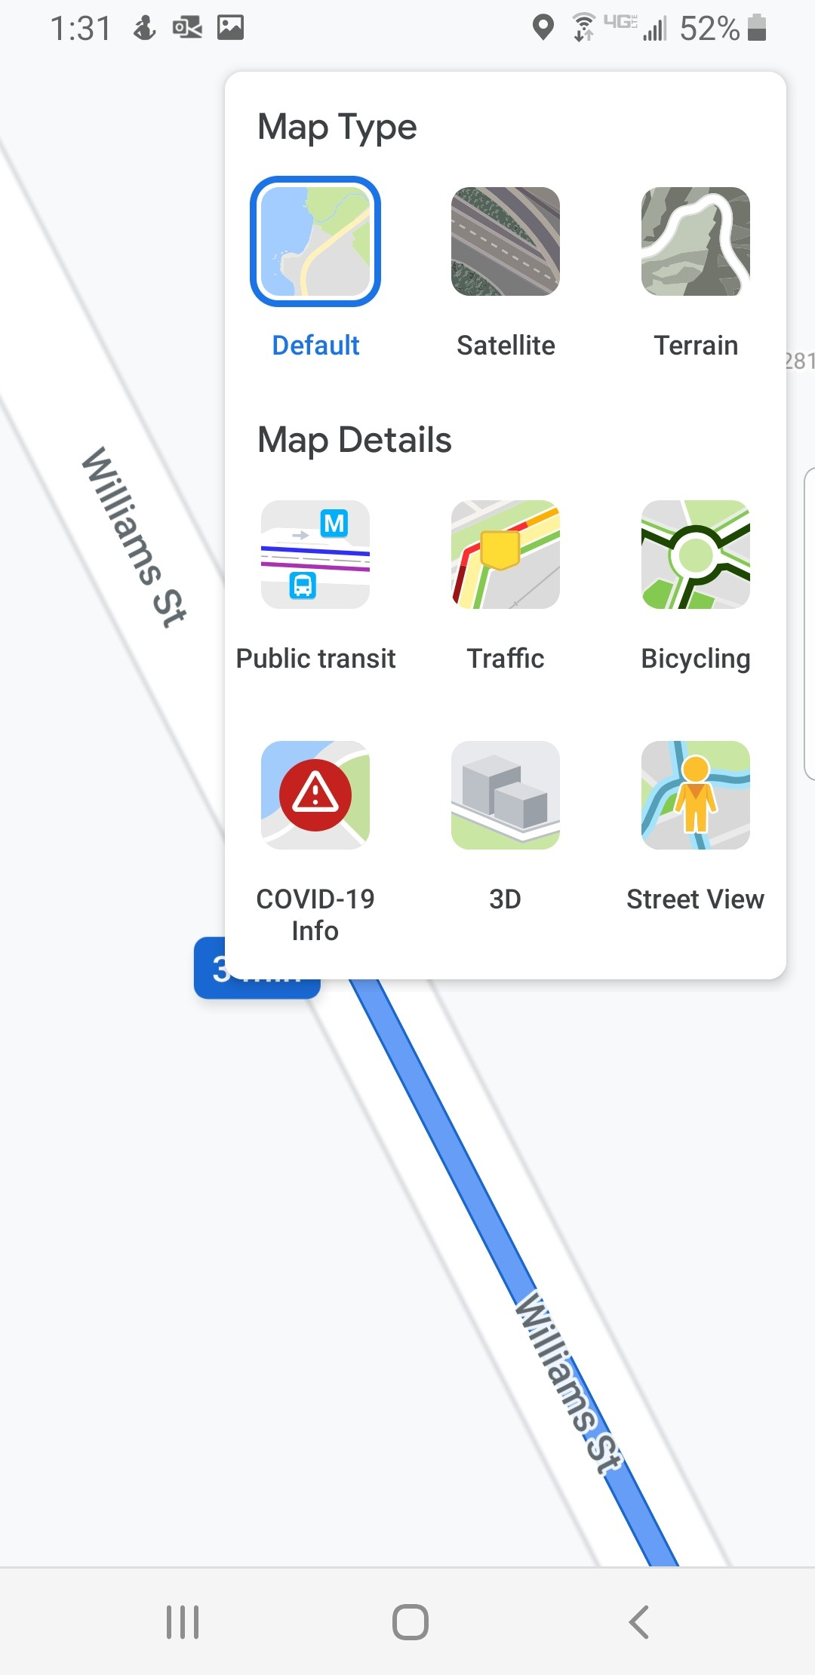

Step 8: Measure the distance between the marked speed humps or from the speed hump to the nearest intersection to verify that they have similar spacing within each block.

Please see below some of the criteria that need to be taken into consideration while marking the location of the speed humps:
- Keep the edge of the speed humps at least 10 feet from catch basins, manholes in the street or fire hydrants.
- Keep the edge of the speed humps, if possible, 10 feet from a driveway. Speed humps can be install in front of a pedestrian path leading to a house unless a resident objected.
- Do not install a speed humps in front of a house with a handicap sign and has ADA wood ramp leading from the house to the driveway.
- Speed humps can be shifted up to 20 ft without contacting traffic engineering. Maintain always a minimum spacing between the speed humps of 250 ft and a maximum spacing of 400 ft.

Block length (ft) |  | No. of Speed Cushions
From | To | No. of Speed Cushions
100 | 800 | 1
>800 | 1100 | 2
>1100 | 1500 | 3
>1500 | 1900 | 4
>1900 | 2400 | 5

