COVID-19 Field Operations Guide

Job Number: 82000-205935
Contractor: Ajax Paving Industries
COVID-19 Field Operations Guidance
March 27, 2020

Personal Responsibilities
- It is critical that individuals DO NOT report to work while they are experiencing illness symptoms such as fever, cough, shortness of breath, sore throat, runny/stuffy nose, body aches, chills, fatigue, lack of smell or taste.
- Individuals should seek medical attention if they develop these symptoms.
Pre-Shift Meeting
Before the start of each shift, we ask that each employee ask themselves these 5 questions:
- Are you having trouble breathing or have you had flu-like symptoms within the past 48 hours, including: fever, cough, shortness of breath, sore throat, runny/stuffy nose, body aches, chills, fatigue, lack of smell or taste?
In the past 14 days:
- Have you, or anyone in your family, been in contact with a person that has tested positive for COVID-19?
- Have you, or anyone in your family, been in contact with a person that is in the process of being tested for COVID-19?
- Have you, or anyone in your family traveled internationally or domestically?
- Have you been medically directed to self-quarantine due to possible exposure to COVID-19?
Employees are encouraged to privately report a “Yes" answer to any of these questions to their direct supervisor via phone call, text or Email. If “Yes,” the worker must NOT report to work that day AND leave the work site immediately if information is discovered during the work shift.

Social Distancing
- Do not host large group meetings. CDC recommends that we avoid gatherings of 10+ people; and when meeting, that we keep a 6-foot distance between people. Perform meetings online or via conference call whenever possible.
- To limit the number of people on a jobsite, allow non-essential personnel to work from home when possible.
- Eliminate hand-shaking, fist bumps, or any other contact greetings.
- Avoid any unnecessary face to face conversations.
- Avoid eating or drinking near others

Jobsite / Office Practices and Personal Hygiene
- Communicate key CDC recommendations (and post signage where appropriate) to your staff and tradespeople:
  - How to protect yourself
  - COVID-19 Frequently Asked Questions
- Place posters that encourage staying home when sick, cough and sneeze etiquette, and hand hygiene at the entrance to your workplace and in other workplace areas where they are likely to be seen.
- Instruct employees to clean their hands often with soap and water for at least 20 seconds. When washing is not possible, use of alcohol-based hand sanitizer that contains at least 60-95% alcohol is encouraged as an alternative.
- Provide soap and water and alcohol-based hand sanitizers (with an alcohol content of 60-95%) in the workplace. Ensure that adequate supplies are maintained. Place hand sanitizers in multiple locations and conference rooms to encourage hand hygiene.
- Do not congregate in lunch areas.
- Avoid sharing tools. Sanitize between uses.
- Do not share personal protection equipment (PPE).
- Sanitize reusable PPE per manufacturer’s recommendation prior to each use.
- Ensure used, disposable PPE is disposed of properly.
- Avoid touching you face, nose, eyes and mouth
- Utilize disposable gloves if required for the task; instruct workers to wash hands after removing gloves.
- Disinfect reusable supplies and equipment.
- Identify specific locations and practices for daily trash such as: paper, hand towels, food containers, etc. Instruct workers responsible for trash removal in proper PPE/hand washing practices.
- Sanitize surfaces, such as doorknobs, keyboards, counters, and other surfaces.
- Do not use a common water cooler. Provide individual water bottles or instruct workers to bring their own.
- Advise workers as a best practice to change work clothes prior to arriving home; and to wash clothes in hot water with laundry sanitizer.
- Don’t stack trades if possible. (The stacking of trades describes project conditions where multiple tradespeople are working simultaneously in a single work area. Stacking creates congestion and crew interference and can also negatively affect productivity.)
- Utilize disposable hand towels and no-touch trash receptacles.
- Request additional/increased sanitation (disinfecting) of portable toilets.
- Avoid cleaning techniques, such as using pressurized air or water sprays that may result in the generation of bioaerosols.

Managing Sick Employees
- Actively encourage sick employees to stay home. Employees who have symptoms of acute respiratory illness are recommended to stay home and not return to work until they are free of fever (100.4° F [38.0° C] or greater using an oral thermometer), signs of a fever, and any other symptoms for at least 72 hours, without the use of fever-reducing or other symptom-altering medicines (e.g. cough suppressants). Employees should notify their supervisor and stay home if they are sick.
- Separate sick employees. CDC recommends that employees who appear to have acute respiratory illness symptoms (i.e. cough, shortness of breath) upon arrival to work or become sick during the day should be separated from other employees and be sent home immediately.
- Communicate your company’s Human Resources practices for managing sick time related to COVID-19.
- For information regarding the Family First Coronavirus Response Act (FFCRA), see the FFCRA Poster and FFCRA FAQ’s page

COVID-19 CDC Guidelines – How to Protect Yourself
How to protect yourself ( Page last update 3/18/20)
Older adults and people who have severe underlying medical conditions like heart or lung disease or diabetes seem to be at higher risk for developing more serious complications from COVID-19 illness. More information on Are you at higher risk for serious illness?

Know How it Spreads
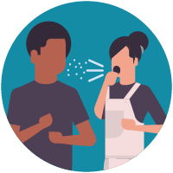
- There is currently no vaccine to prevent coronavirus disease 2019 (COVID-19).
- The best way to prevent illness is to avoid being exposed to this virus.
- The virus is thought to spread mainly from person-to-person.
  - Between people who are in close contact with one another (within about 6 feet).
  - Through respiratory droplets produced when an infected person coughs or sneezes.
- These droplets can land in the mouths or noses of people who are nearby or possibly be inhaled into the lungs.

Take steps to protect yourself
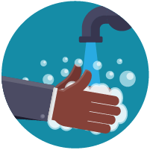

Clean your hands often
- Wash your hands often with soap and water for at least 20 seconds especially after you have been in a public place, or after blowing your nose, coughing, or sneezing.
- If soap and water are not readily available, use a hand sanitizer that contains at least 60% alcohol. Cover all surfaces of your hands and rub them together until they feel dry.
- Avoid touching your eyes, nose, and mouth with unwashed hands.
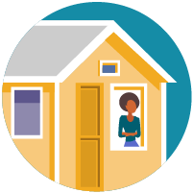

Avoid close contact
- Avoid close contact with people who are sick
- Put distance between yourself and other people if COVID-19 is spreading in your community. This is especially important for people who are at higher risk of getting very sick.

Take steps to protect others
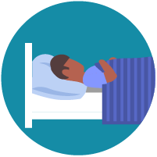

Stay home if you’re sick
- Stay home if you are sick, except to get medical care. Learn what to do if you are sick.
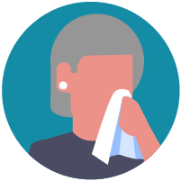

Cover coughs and sneezes
- Cover your mouth and nose with a tissue when you cough or sneeze or use the inside of your elbow.
- Throw used tissues in the trash.
- Immediately wash your hands with soap and water for at least 20 seconds. If soap and water are not readily available, clean your hands with a hand sanitizer that contains at least 60% alcohol.


Wear a facemask if you are sick
- If you are sick: You should wear a facemask when you are around other people (e.g., sharing a room or vehicle) and before you enter a healthcare provider’s office. If you are not able to wear a facemask (for example, because it causes trouble breathing), then you should do your best to cover your coughs and sneezes, and people who are caring for you should wear a facemask if they enter your room. Learn what to do if you are sick.
- If you are NOT sick: You do not need to wear a facemask unless you are caring for someone who is sick (and they are not able to wear a facemask). Facemasks may be in short supply and they should be saved for caregivers.
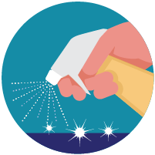

Clean and disinfect
- Clean AND disinfect frequently touched surfaces daily. This includes tables, doorknobs, light switches, countertops, handles, desks, phones, keyboards, toilets, faucets, and sinks.
- If surfaces are dirty, clean them: Use detergent or soap and water prior to disinfection.
To disinfect:
Most common EPA-registered household disinfectants will work. Use disinfectants appropriate for the surface.
Options include:
- Diluting your household bleach.
To make a bleach solution, mix:
  - 5 tablespoons (1/3rd cup) bleach per gallon of water
OR
  - 4 teaspoons bleach per quart of water
Follow manufacturer’s instructions for application and proper ventilation. Check to ensure the product is not past its expiration date. Never mix household bleach with ammonia or any other cleanser. Unexpired household bleach will be effective against coronaviruses when properly diluted.
- Alcohol solutions.
Ensure solution has at least 70% alcohol.
- Other common EPA-registered household disinfectants.
Products with EPA-approved emerging viral pathogens pdf icon[7 pages]external icon claims are expected to be effective against COVID-19 based on data for harder to kill viruses. Follow the manufacturer’s instructions for all cleaning and disinfection products (e.g., concentration, application method and contact time, etc.).

CDC: staying home when sick
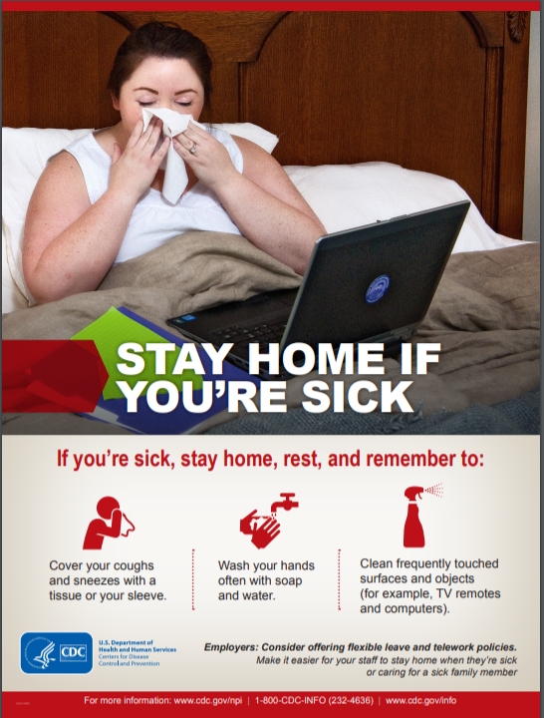
CDC: cough and sneeze etiquette
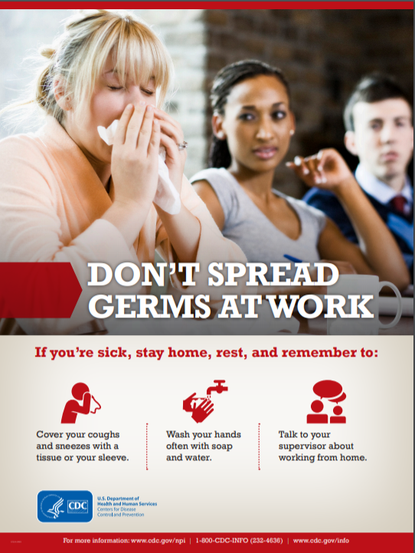
CDC: hand hygiene
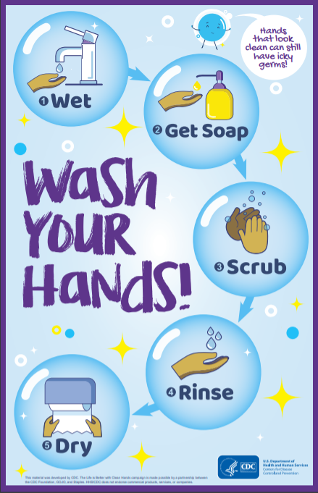
FFCRA Poster - Last Update 3/25/20
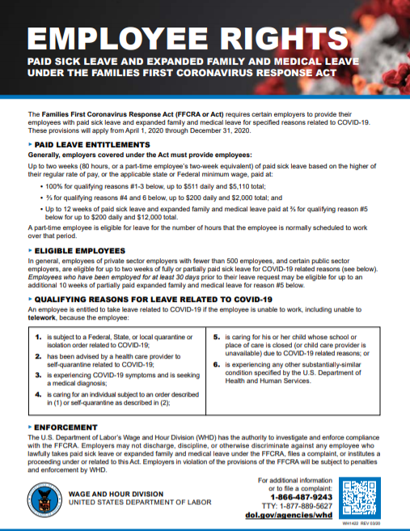
Document Revision History

Date | Document History and Modifications | Author
3/26/20 | Document Creation and Initial Release | M. Payne

